Physical Science Worksheet: Acceleration

Problem

1. During a race, a sprinter increases from 5.0 m/s to 7.5 m/s over a period of 1.25 s. What is the sprinter’s average acceleration during this period?

2. A plastic ball is dropped out an open window from a height of 20.0 m.
a. Neglecting air resistance and using acceleration due to gravity (–9.80 m/s²), calculate the velocity of the ball when it hits the ground.
b. When does the ball hit the ground?

3. A person is standing on the roof of a tall building. She throws a ball from the top of the building in such a way that when the ball passes a window cleaner who is 2.0 m from the top, it is falling at a speed of 7.0 m/s. It takes another 2.9 s to reach the ground.
a. How tall is the building?
b. How fast is the ball moving when it hits the ground?

4. A 0.250-kg cart moves on a straight horizontal track. The graph of velocity, v, versus time, t, for the motion of the cart is given below.

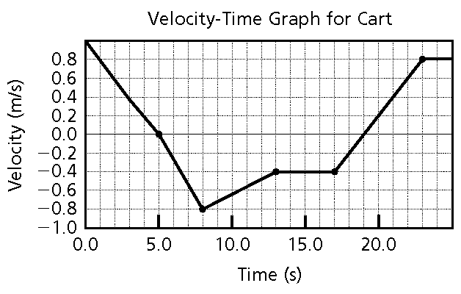

a. Identify every time, t, for which the cart is at rest.
b. Identify every time interval for which the speed (the magnitude of the velocity) of the cart is increasing.

5. Use the velocity-time graph below to calculate the velocity of the object whose motion is plotted on the graph.

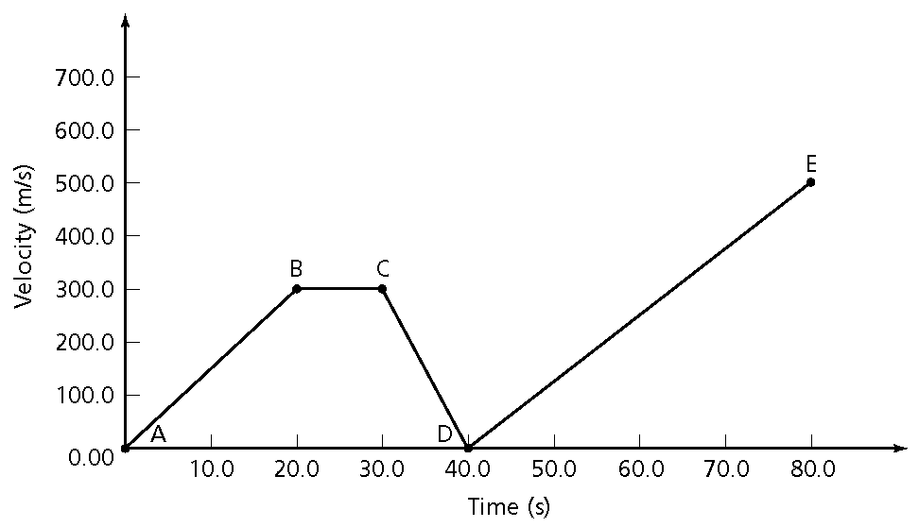
a. What is the acceleration between the points on the graph labeled A and B?
b. What is the acceleration between the points on the graph labeled B and C?
c. What is the acceleration between the points on the graph labeled D and E?
d. What is the total distance that the object travels between points B and C?

6. If you throw a ball straight upward, it will rise into the air and then fall back down toward the ground. Imagine that you throw the ball with an initial velocity of 13.7 m/s.
a. How long does it take the ball to reach the top of its motion?
b. How far will the ball rise before it begins to fall?
c. What is its average velocity during this period?

7. A car is traveling at 20 m/s when the driver sees a ball roll into the street. From the time the driver applies the brakes, it takes 2 s for the car to come to a stop.
a. What is the average acceleration of the car during that period?
b. How far does the car travel while the brakes are being applied?

8. A hot air balloon is rising at a constant speed of 1.00 m/s. The pilot accidentally drops his pen 10.0 s into the flight.
a. How far does the pen drop?
b. How fast is the pen traveling when it hits the ground, ignoring air resistance?

9. A sudden gust of wind increases the velocity of a sailboat relative to the water surface from 3.0 m/s to 5.5 m/s over a period of 30.0 s. What is the average acceleration of the sailboat?

10. Anna walks off the end of a 10.0-m diving platform.
a. What is her acceleration in m/s² toward the pool?
b. How long does it take her to reach the water?
c. What is her velocity when she reaches the water?

11. A rocket used to lift a satellite into orbit undergoes a constant acceleration of 6.25 m/s². When the rocket reaches an altitude of 45 km above the surface of Earth, it is traveling at a velocity of 625 m/s. How long does it take for the rocket to reach this speed?

12. On the surface of Mars, the acceleration due to gravity is 0.379 times as much as that on the surface of Earth. A robot on Mars pushes a rock over a 500.0-m cliff.
a. How long does it take the rock to reach the ground below the cliff?
b. How fast is the rock traveling when it reaches the surface?
c. How long would it take the rock to fall the same distance on the surface of Earth?

13. A sky diver jumps from an airplane 1000.0 m above the ground. He waits for 8.0 s and then opens his parachute. How far above the ground is the sky diver when he opens his parachute?
Physical Science Worksheet: Acceleration
Answer Section

PROBLEM

1. ANS:
2.0 m/s²

PTS: 1 DIF: 2 REF: 2 OBJ: 3
STA: PS 29

2. ANS:
a. Using the ground as d_{f} = 0, the initial conditions for the ball are di = + 20.0 m, v_{i} = 0.
v_{f}² = v_{i}² + 2a(d_{f} – d_{i})
= 0² + 2(–9.80 m/s²)(0 – 20.0 m)
= 392 m²/s²
v_{f} = ±
= ±19.8 m/s
Because the velocity of the ball is downward toward the ground, we know the negative value is correct, v_{f} = –19.8 m/s.
b. v_{f} = v_{i} + at_{f}
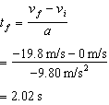

PTS: 1

3. ANS:
a. The final position, d_{f}, of an accelerating object is described by the equation
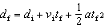
where
d_{i} = initial position
v_{i} = initial velocity
t_{f} = final time, where initial time ti 5 0
a = acceleration
Given
d_{i} = 2.0 m from the top
v_{i} = 7.0 m/s
t_{f} = 2.9 s
a = 9.80 m/s² (acceleration due to gravity)
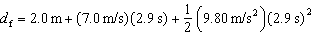
The building is 64 m tall.

b. The average acceleration a of an object is described by the equation
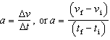
where v_{f} = final velocity, v_{i} = initial velocity, t_{f} = final time, t_{i} = initial time.
This can be rearranged to find final velocity: v_{f} = v_{i} + a(t_{f} – t_{i})

Given
v_{i} = 7.0 m/s
t_{f} = 2.9 s
t_{i} = 0 s
a = 9.80 m/s²
v_{f} = 7.0 m/s + (9.80 m/s²)(2.9 s)
v_{f} = 35 m/s
The ball is moving at 35 m/s when it hits the ground.

PTS: 1

4. ANS:
a. The cart is at rest at t = 5.0 s and at t = 19.0 s.
b. The speed of the cart is increasing during the interval from t = 5.0 s to t = 8.0 s and during the interval from t = 19.0 s to t = 23.0 s.

PTS: 1

5. ANS:
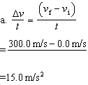

b. Δv = 0, therefore a = 0
(no acceleration)
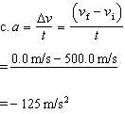

d. d = vt
= 300.0 m/s × 10.0 s
= 3.00 × 10³ m

PTS: 1

6. ANS:
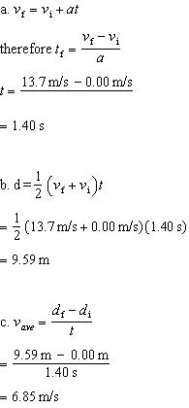

PTS: 1

7. ANS:
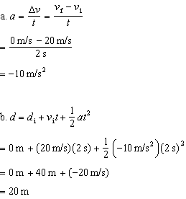

PTS: 1

8. ANS:
a. The pen falls from the altitude of the balloon at 10 s.
d = vt
= (1.00 m/s)(10.0 s)
= 10.0 m
b. v_{f}² = v_{i}² + 2a(d_{f} – d_{i})
= 0 + 2(9.80 m/s²)(10.0 m – 0.00 m)
= 196 m²/s²
v = 14.0 m/s

PTS: 1

9. ANS:
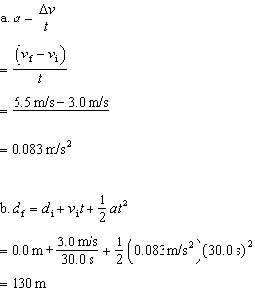

PTS: 1

10. ANS:
a. Her acceleration due to gravity is 9.80 m/s².
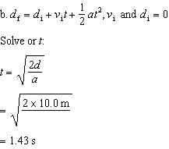
c. v_{f} = v_{i} + at
= 0.0 m/s + (9.80 m/s²)(1.43 s)
= 14.0 m/s

PTS: 1

11. ANS:
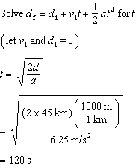

PTS: 1

12. ANS:
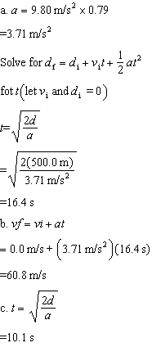

PTS: 1

13. ANS:
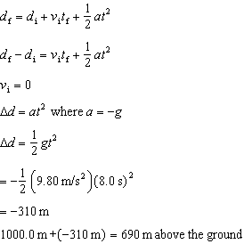

PTS: 1

