Chemistry Worksheet Stoichiometry
Multiple Choice
1. What is the SI base unit used to measure the amount of a substance?
A. | Kelvin | B. | Kilogram | C. | Meter | D. | Mole
2. Calculate the number of molecules in 4.0 mol H₂O.
A. | 0.60 x 10²³ molecules | C. | 2.4 x 10^{–23} molecules
B. | 2.4 x 10²⁴ molecules | D. | 2.4 x 10²³ molecules
3. How many moles of Ag contain 4.49 x 10²³ atoms Ag?
A. | 0.745 x 10²⁴ mol | C. | 0.745 mol
B. | 0.745 x 10²³ mol | D. | 27.0 mol
4. Calculate the number of atoms in 13.2 mol copper.
A. | 2.19 x 10²³ atoms | C. | 7.95 x 10^{–23} atoms
B. | 7.95 x 10²⁴ atoms | D. | 79.5 x 10²³ atoms
5. Copper (Cu) is a transition element used in the making of coins. Calculate the mass in grams of 0.0420 moles of copper.
A. | 0.00697 g | B. | 0.252 g | C. | 2.67 g | D. | 6.61 g
6. Determine the mass in grams of 0.0489 mol cobalt.
A. | 0.00812 g | B. | 0.294 g | C. | 2.88 g | D. | 0.000830 g
7. How many moles of calcium are in 425 g calcium (Ca)?
A. | 10.6 mol | B. | 70.5 mol | C. | 171 mol | D. | 255 mol
8. Copper is one of a group of metals called the coinage metals. How many atoms of copper (Cu) are in a pure copper coin weighing 12.0 g?
A. | 0.0313 x 10²³ atoms | C. | 1.10 x 10²³ atoms
B. | 0.187 x 10²³ atoms | D. | 1.13 x 10²³ atoms
9. A balloon contains 4.50 x 10²² atoms of helium (He) gas. Calculate the mass of helium in grams.
A. | 0.185 g | B. | 0.0185 g | C. | 0.0747 g | D. | 0.299 g
10. What is the molar mass of Ca(OH)₂?
A. | 57.008 g/mol | C. | 73.088 g/mol
B. | 73.080 g/mol | D. | 74.092 g/mol
11. What is the mass of 2.25 moles of sulfuric acid (H₂SO₄)?
A. | 50.0 g | B. | 98.0 g | C. | 112 g | D. | 220 g
12. Determine the number of moles present in 32.5 g aluminum chloride.
A. | 0.244 mol | B. | 4.10 mol | C. | 1.21 mol | D. | 720 mol
13. What is the mass in grams of 1.02 x 10²⁴ atoms manganese (Mn)?
A. | 0.112 x 10¹ g | C. | 9.30 x 10^{–1} g
B. | 0.169 x 10¹ g | D. | 9.30 x 10¹ g
14. How many moles are present in 21.2 g hydrochloric acid?
A. | 0.582 mol | B. | 1.72 mol | C. | 21.0 mol | D. | 128 mol
15. The SI unit of molar mass is the _____.
A. | gram. | B. | gram/mole. | C. | mole. | D. | mole/gram.
16. How many moles of oxygen atoms do 1.5 moles of CO₂ contain?
A. | 1 mol | B. | 1.5 mol | C. | 2 mol | D. | 3.0 mol
17. Which compound has the smallest molar mass?
A. | CO | B. | CO₂ | C. | H₂O | D. | H₂O₂
18. One mole of silicon (Si) has a mass of 28.086 g, and one mole of carbon has a mass of 12.011 g. What is the mass of one mole of silicon carbide (SiC)?
A. | 2.340 g | C. | 40.097 g
B. | 16.075 g | D. | 3.3734 x 10² g
19. Methane (CH₄) contains 75% carbon. What percentage of methane is hydrogen?
A. | 4% | B. | 6% | C. | 25% | D. | 33%
20. The mole ratio of carbon to hydrogen to oxygen in a compound is 1 mol C : 2 mol H : 1 mol O. What is the empirical formula of the compound?
A. | CHO | B. | CH₂O | C. | C₂HO₂ | D. | C₂H₂O₂
Short Answer
21. UF₆ is a gas used in the production of fuel for nuclear power plants. How many moles of the gas are in 100.0 g of UF₆?
22. CCl₃CF₃ is a chlorofluorocarbon responsible for the destruction of the ozone layer in Earth’s atmosphere. How many molecules of the liquid are in 1.0 g of CCl₃CF₃?
23. Lead (Pb) is used to make a number of different alloys. What is the mass of lead present in an alloy containing 0.15 mol of lead?
Problem
Calculate the number of moles of the substance that contains the following number of representative particles.
24. 8.92 x 10²³ atoms of barium
25. 5.50 x 10²⁵ molecules of carbon monoxide
26. 2.66 x 10²² formula units of potassium iodide
Determine the mass in grams of each of the following quantities.
27. 1.24 moles of beryllium
28. 3.35 moles of calcium
29. 0.155 mole of sulfur
Calculate the number of moles in each of the following samples.
30. 6.35 g lithium
31. 346 g zinc
32. 115 g nickel
33. 3.75 g calcium carbide (CaC₂)
How many atoms are in the following samples?
34. 1.24 g cobalt
35. 0.575 g cesium
36. 65.6 g silicon
Calculate the number of moles in each of the following quantities.
37. atoms of each element in 3.35 moles of aspirin (C₉H₈O₄)
38. positive and negative ions in 1.75 moles of calcium fluoride (CaF₂)
Determine the molar mass of each of the following compounds.
39. formic acid (CH₂O₂)
40. ammonium dichromate ((NH₄)₂Cr₂O₇)
Chemistry Review
Answer Section
MULTIPLE CHOICE
1. D
The mole is an SI base unit used to measure the amount of a substance.
2. B
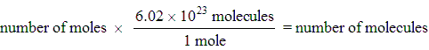
3. C
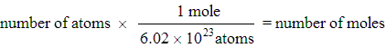
4. B
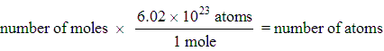
5. C
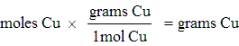
6. C
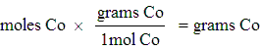
7. A
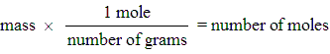
8. D
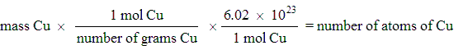
9. D
10. D
The molar mass of Ca(OH)₂ is calculated after adding the masses of all the elements.
11. D
Step 1:
Step 2:
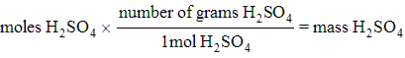
12. A
13. D
14. A
15. B
16. D
17. C
18. C
19. C
20. B
SHORT ANSWER
21.
22.
23.
PROBLEM
24. 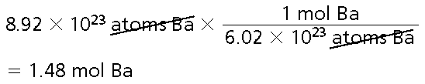
25. 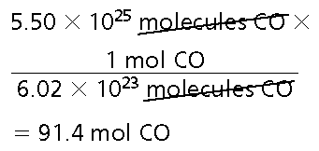
26. 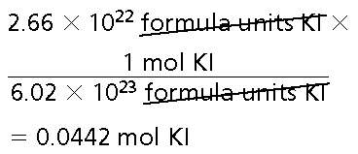
27. 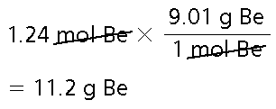
28. 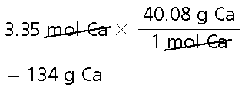
29. 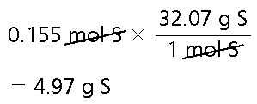
30. 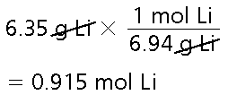
31. 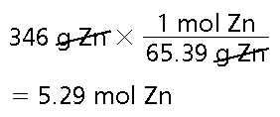
32. 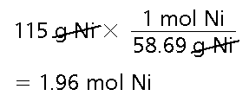
33. 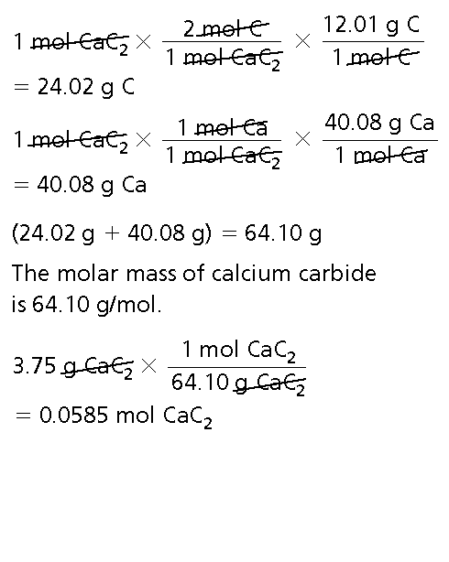
34. 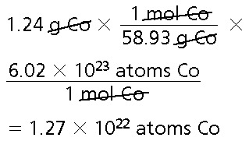
35. 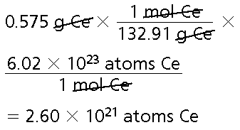
36. 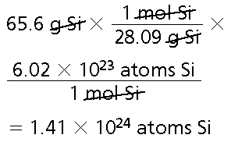
37. 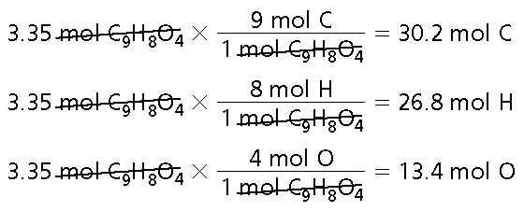
38. 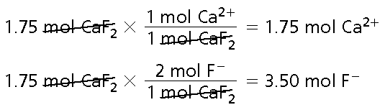
39. 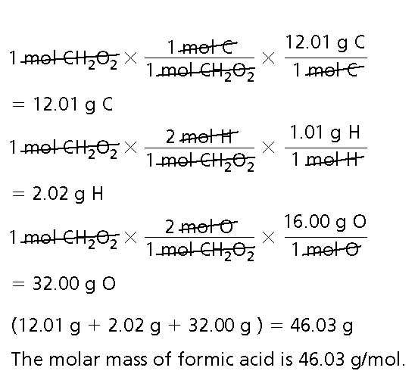
40. 