Chemistry Worksheet: Naming Compounds

Matching
Match each of the lettered structures (a–l) to the following names.
A. | 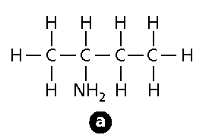 | G. | 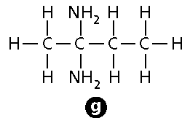
B. | 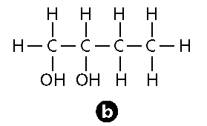 | H. | 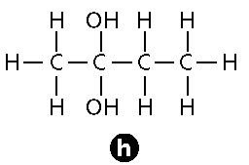
C. | 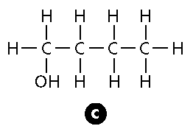 | I. | 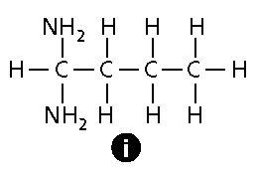
D. | 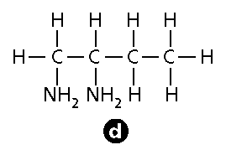 | J. | 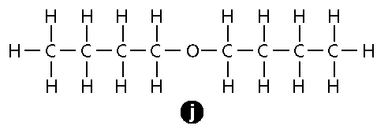
E. | 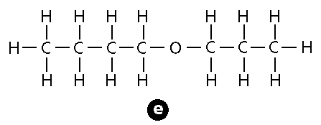 | K. | 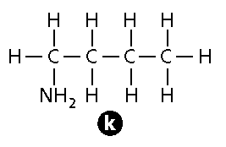
F. | 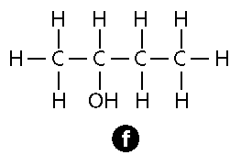 | L. | 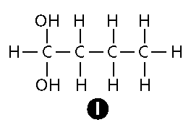

1. 1-butanol
2. 2-butanol
3. 1,1-butanediol
4. 2,2-butanediol
5. 1,2-butanediol
6. butyl ether
7. butylpropyl ether
8. 1-butylamine
9. 2-butylamine
10. 1,1-butyldiamine
11. 2,2-butyldiamine
12. 1,2-butyldiamine

Multiple Choice
13. The correct IUPAC name of the compound 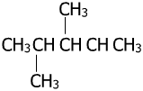 is ____.
A. 3,4-dimethylpentane B. 2,3-dimethylbutane C. 2,3-dimethylpentane D. 2,2,3-dimethylbutane

14. The structure of 3-ethyl-5,7-dimethyl-5-propylnonane is ____.
A. 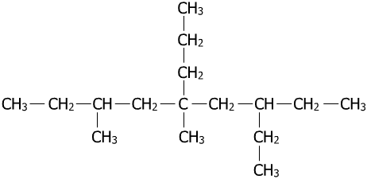 B. 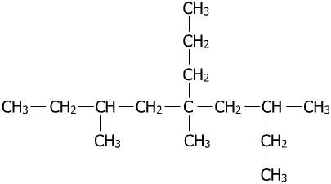 C. 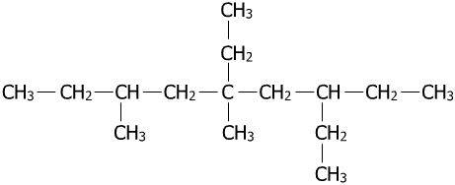 D. 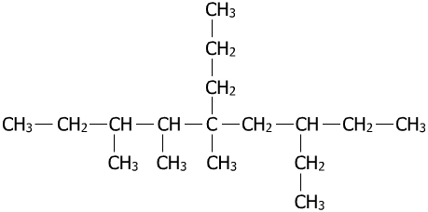
15. Name the cycloalkane given below.
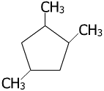
A. 1,2,4-trimethylcyclohexane B. 1,2,4-dimethylcyclopentane C. 1,2,4-trimethylcyclopentane D. 1,3,5-trimethylcyclopentane

16. The correct structural formula of 1,2-diethyl-2,3-dimethyl-6-propylcyclooctane is ____.
A. 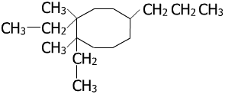 B. 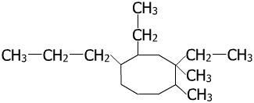 C. 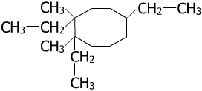 D. 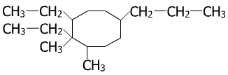

17. The correct condensed structure of a compound having the IUPAC name 6-ethyl-6,7-dimethyl-2,4-dioctyne is ____.
A. 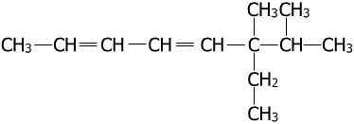 B. 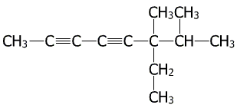 C. 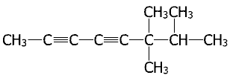 D. 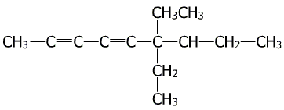
Choose the letter of the correct name for each structure.
18. CH₃CH₂CH₂CH₂CH₃
A. propane B. pentane C. hexane

19. CH₃CH=CHCH₂CH₃
A. 2-pentene B. 3-pentene C. 4-pentene

20. CH₃CH₂CCCH₃
A. 4-pentyne B. 3-pentane C. 2-pentyne

21. CH₃CH₂CH=CHCH₂CH₂CH=CH₂
A. 1,5-octadiene B. 3,7-octadiene C. 4,8-dioctene

22. CH₃CH₂CCCH₂CH₃
A. 3-hexene B. 3-hexyne C. 3-pentyne

23. What is the molecular formula of benzene?
A. C₆H₆ B. C₆H₁₂ C. C₆H₁₄ D. C₁₂H₁₂

Completion

24. The IUPAC name of a compound represented by the line structure 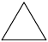 is ____________________.
25. The IUPAC name of is ____________________.
26. The IUPAC name of 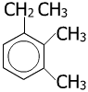 is ____________________.
The structural formula of an organic compound can sometimes be written in a variety of ways, but sometimes structural formulas that appear similar can represent different compounds. The structural formulas below are ten ways of representing compounds having the molecular formula C₆H₁₄.
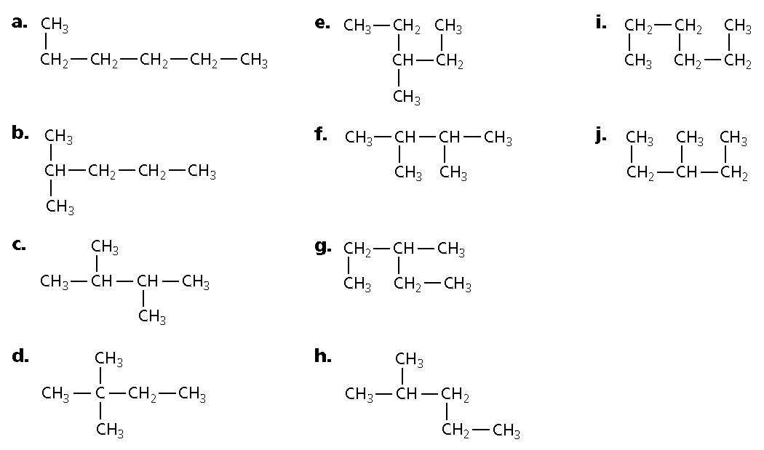
27. Write the correct name for the structural formula labeled a____________________.
28. Write the correct name for the structural formula labeled b____________________.
29. Write the correct name for the structural formula labeled c____________________.
30. Write the correct name for the structural formula labeled d____________________.
31. Write the correct name for the structural formula labeled e____________________.
32. Write the correct name for the structural formula labeled f____________________.
33. Write the correct name for the structural formula labeled g____________________.
34. Write the correct name for the structural formula labeled h____________________.
35. Write the correct name for the structural formula labeled i____________________.
36. Write the correct name for the structural formula labeled j____________________.
Short Answer

37. Draw the structures of 2,2,3-pentanetriamine and 1,3,5-cyclohexanetriol.

Use the IUPAC rules to name the following structures.

38. 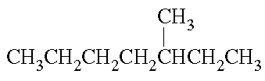

39. 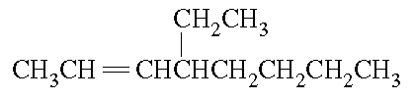

40. 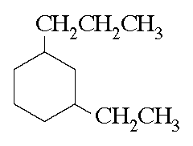
41. 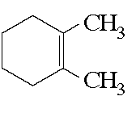

42. 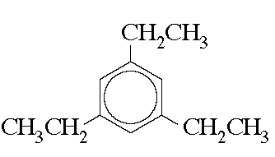

43. 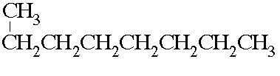

44. 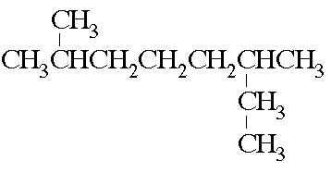

45. 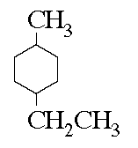

46. 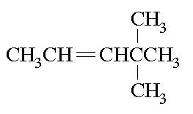

47. 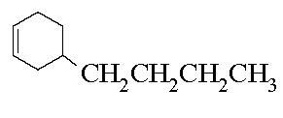

48. 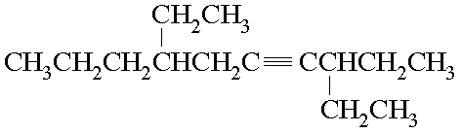

49. 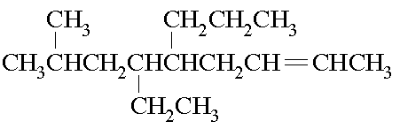

50. 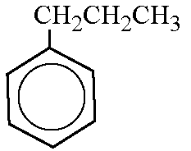

51. 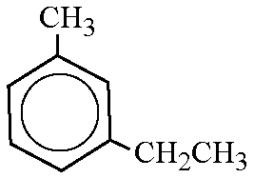

52. CH₃CH₂CH₂CH₂CH₃

53. 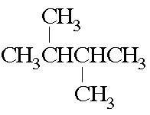

54. 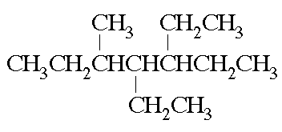

55. 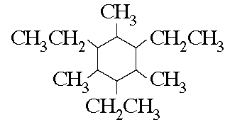

Draw the structure of each of the following alkanes.

56. 2-methylheptane

57. 2,3,4-trimethylpentane

58. 4-propyloctane

59. 3,4-diethylhexane

60. 2,2,4,4-tetramethylhexane

61. 1-ethyl-3-methyl-2-propylcyclopentane

62. Draw the structure of the following cycloalkane:
1-ethyl, 2-propylcyclobutane

63. Balance the following equation for the reaction.
_____Cr(s) + _____H₃PO₄(aq) _____H₂(g) + _____CrPO₄(s)

64. Balance the following equation for the reaction.
_____SiO₂(s) + _____ C(s) _____SiC(s) + _____ CO(g)

65. Balance the following equation for the reaction.
_____ N₂O₄(l) + _____ N₂H₄(l) _____ N₂(g) + _____ H₂O(g)

66. Balance the following equation for the reaction.
_____ Ni(CO)₄(g) _____ Ni(s) + _____ CO(g)

Each chemical equation below contains at least one error. Identify the error or errors and then write the correct chemical equation for the reaction.

67.

68.

69.

70.

71.

Balance the following equations.

72. SnS₂(s) + O₂(g) SnO₂(s) + SO₂(g)

73. C₂H₆(g) + O₂(g) CO₂(g) + H₂O(g)

74. Al(s) + HCl(aq) AlCl₃(aq) + H₂(g)

75. CoCO₃(s) CoO(s) + CO₂(g)

Problem

76. Write the IUPAC name of the following structure:
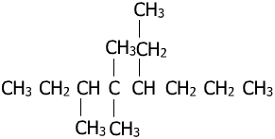

77. Draw the structure of 3,4,6-triethyl-5-methyloctane.

78. Write the IUPAC name of the following compound:
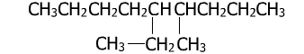

79. Determine the IUPAC name of the following structure:

80. Write the IUPAC name of the following compounds:
a. 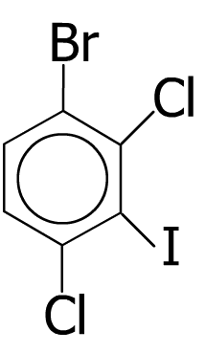
b. 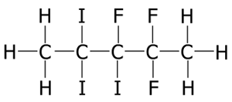

81. Write the IUPAC name of following compound:

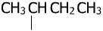
Br

Add the appropriate coefficient to balance the following chemical equations.

82.

83.

84.

85.

86.

87.

