Chemistry Study Guide: Ideal Gas Law

Matching

Match the following terms with their correct descriptions.
a. | increases | c. | stays the same
b. | decreases

____ 1. An aerosol can of air freshener is sprayed into a room. What happens to the pressure of the gas if its temperature stays constant?

____ 2. A leftover hamburger patty is sealed in a plastic bag and placed in the refrigerator. What happens to the volume of the air in the bag?

____ 3. The volume of air in human lungs increases before it is exhaled. What happens to the temperature of the air in the lungs to cause this change, assuming pressure stays constant?

____ 4. What happens to the pressure of the gas in an inflated expandable balloon if the temperature is increased?

____ 5. What happens to the pressure of a gas in a lightbulb a few minutes after the light is turned on?

____ 6. The room temperature increases from 20°C to 24°C. What happens to the pressure inside a cylinder of oxygen contained in the room?

Short Answer

PV=nRT

Ptotal=P1+P2+P3...

In Figure 1, a simple mercury barometer is made by filling a long glass tube with mercury and then inverting the open end of the tube into a bowl of mercury. Answer the following questions about the simple mercury barometer shown here.

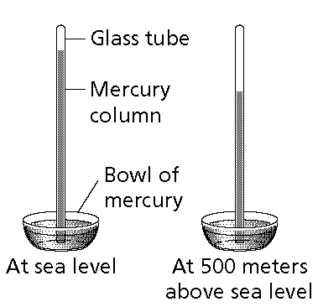

7. When the barometer in Figure 1 is moved to a higher elevation, such as an altitude of 5000 meters, the column of mercury changes as shown in Figure 2. Why is the mercury column lower in Figure 2 than in Figure 1?

8. Suppose the barometer in Figure 1 was carried into an open mine 500 meters below sea level. How would the height of the mercury column change? Explain why.

9. What prevents mercury from flowing out of the glass tube into the bowl of mercury?

10. Suppose a tiny crack formed at the top of the barometer’s glass tube. How would this event affect the column of mercury? Explain why.

11. What occupies the space above the mercury column in the barometer’s glass tube?

12. If a gas with an odor is released in a room, it can quickly be detected across the room because it

13. A mixture of four gases exerts a total pressure of 860 mm Hg. Gases A and B each exert 220 mm Hg. Gas C exerts 110 mm Hg. What pressure is exerted by gas D?

14. The equation for the combined gas law can be used instead of which of the following equations?

15. What volume will one mole of a gas occupy under standard temperature and pressure?

16. The volume of a sample of helium is 4.50 mL at 20.0°C and 203.0 kPa. What will its volume be at 10.0°C and 203.0 kPa?

17. Standard temperature is exactly

18. The ideal gas law combines Boyle's law, Charles's law, Gay-Lussac's Law and

19. What is the process by which molecules of a gas randomly encounter and pass through a small opening in a container?

20. What is an example of effusion?

21. Who developed the concept that the total pressure of a mixture of gases is the sum of their partial pressures?

22. If the temperature of a fixed quantity and volume of gas changes, what also changes?

23. What is Gay-Lussac’s law:

24. How many moles of helium gas are contained in a 4.0-L flask at STP?

25. One liter of a gas has a pressure of 150.00 kPa at 25.0°C. If the pressure increases to 600.0 kPa and the temperature to 100.0°C, what would be the new volume of the gas?

26. What does the constant bombardment of gas molecules against the inside walls of a container produce?

27. Why does a can collapse when a vacuum pump removes air from the can?

28. Which instrument measures atmospheric pressure?

29. Why do your ears "pop" in an airplane?

30. What variable is mentioned in the ideal gas law that is assumed to be constant in the other gas laws?

31. What are standard temperature and pressure? Why is a standard necessary?

32. What is the equation for the ideal gas law?

33. Why does the air pressure inside the tires of a car increase when the car is driven?

