CH 27-1 & CH 27-2 Flatworms & Roundworms-Classroom Copy
Write the questions! Underline the answers!....
1. Name two types of unsegmented worms. ___________________________________________
2. To what phylum do the flatworms belong? __________________________________________
3. Flatworms are soft, flattened worms that have tissues and internal ______________________________
4. A fluid filled body cavity that is lined with tissue is called a _______________________________
5. What type of symmetry does a flatworm have? ______________________________
6. Flatworms rely on __________________ for respiration and excretion.
7. The muscular tube near the mouth that aids in getting food is called the _________________________
8. How do parasitic flatworms obtain their food? ____________________________________________
9. What type of flatworm has no digestive tract at all? _____________________________
10. What do flame cells do? _______________________________________________________________
11. What is ganglia? ____________________________________________ Do flatworms have ganglia? ______
12. What structure detects light in a flatworm? ____________________________
13. Use Fig 27-3 to help you label the flatworm
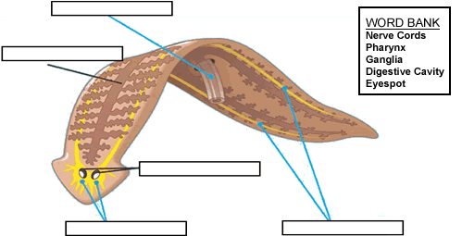
14. What is a hermaphrodite? ____________________________________________________________
15. _____________________is when an organism splits in two and each half grows to become a complete new organism.
16. Turbellarians are _______________________________ flatworms that live in marine and fresh water.
17. Flukes are ___________________________ flatworms that infect internal organs of their host.
18. How does a blood fluke infect a human? ______________________________________
19. Blood fluke embryos develop inside what organism? _____________________
20. Schistosomiasis is widespread in tropical areas that lack proper ____________________ treatment.
21. Tapeworms are long, parasitic flatworms that are adapted to life inside the ______________________ of their hosts. Do tapeworms have a digestive tract? ______
22. What is the head of the adult tapeworm called? _____________________________
23. What are proglottids? _________________________________________________________________
24. How are tapeworm zygotes passed out of the body? _________________________________________
25. The larvae of a tapeworm grow in the ___________________________ of the intermediate host.

Reading Guide 27-2 - Roundworms
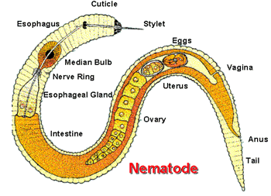
1. Roundworms are ________________ worms that have __________________ and digestive systems.
2. List the two openings a roundworm has. __________________________________________
3. Name the cavity between the endoderm and mesoderm layers. __________________________
4. A pseudocoelom is a ________________ coelom
__________________________________________
5. Which body systems are more complex; the free-living roundworms or the parasitic forms?
__________________________________________
6. Name and the five physiological functions of the roundworm.
1. ________________________________________________________________________
2. ________________________________________________________________________
3. ________________________________________________________________________
4. ________________________________________________________________________
5. ________________________________________________________________________
7. Free living roundworms that are predators use _________________ mouthparts and _______________ to catch their food
8. What type of fertilization do roundworms use to reproduce? ___________________________
9. Parasitic roundworms include _______________-causing worms, filarial worms, ____________ worms, and hookworms.
10. Name the place where the adult Trichinella roundworm lives? ________________________
11. Why is Trichinosis so painful for humans? _______________________________________
_____________________________________________________________________________
12. How is Trichinosis spread to humans? ___________________________________________
_____________________________________________________________________________
13. Filial worms are _______________ worms that live in the __________ and _________ _____________ of birds and mammals, including humans.
14. What is Elephantiasis and what causes it? ________________________________________
_____________________________________________________________________________
15. Look at Careers in Biology - Meat Inspector
If we did not have meat inspectors here in the U.S., what possible problems could we as a consumer of meat face? ______________________________________________________________
16. What is the main symptom that Ascarid worms cause? ______________________________
17. How is the parasite Ascarid lumbricoides spread? _____________________________________
Look at the figure below.
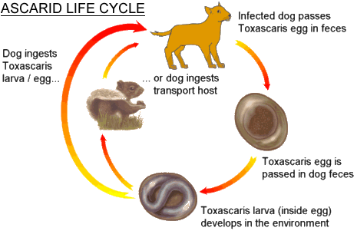
18. How are the eggs released from the body? ________________________________________
19. How do the worms get back into the host (dogs) ____________________________________
20. Name two species (besides humans) that are affected by Ascarid worms? _____________________________________
21. Describe the process of how a hookworm infects its host. ____________________________
______________________________________________________________________________
22. Caenorhabditis elegans is a free-swimming roundworm. This roundworm was the first of all animals to have what done? _____________________________________________________
Please fill in missing material on Roundworms in the below table:
Organism | Disease | Route of Infection | Description
Trichinella | Trichinosis |  | Larvae burrow into muscle tissue
Filarial Worms |  | Bite of insect carrying worms | Worms block fluids, causing swelling in legs
Ascaris | Roundworms |  | Worms block intestine, interfering with digestion
 | Hookworm | Bare skin contact with soil

